TC-CUS-006
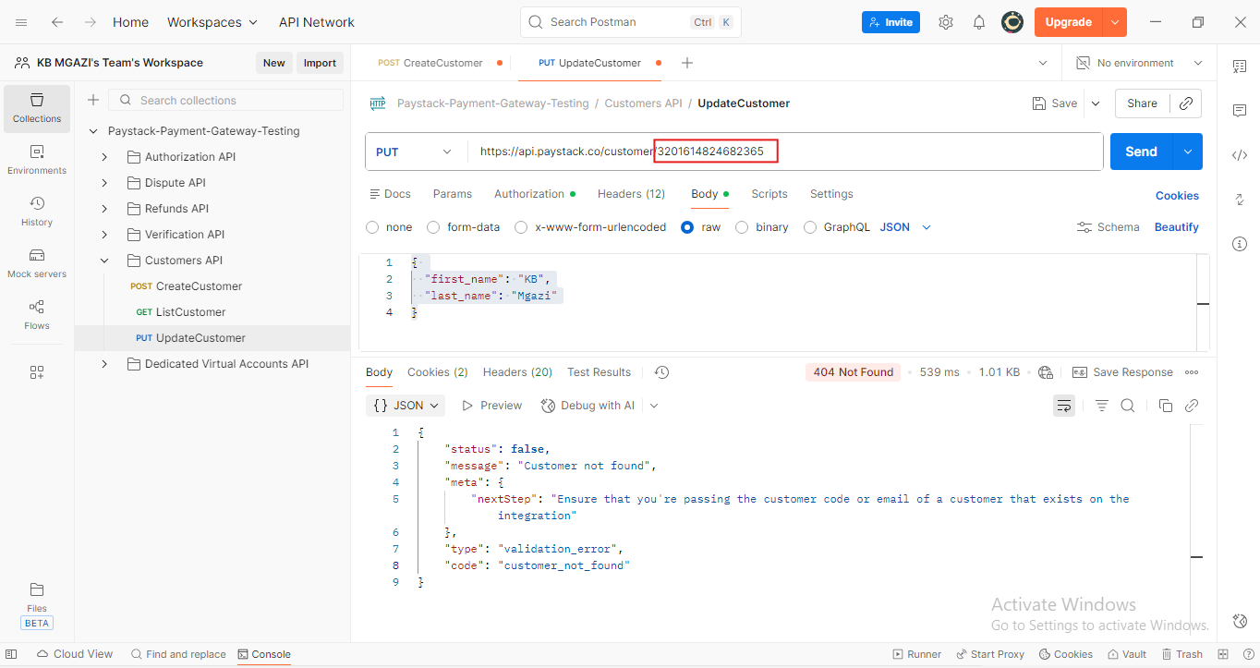
Request:
{
"first_name": "KB",
"last_name": "Mgazi"
}

Response:
{
"status": false,
"message": "Customer not found",
"meta": {
"nextStep": "Ensure that you're passing the customer code or email of a customer that exists on the integration"
},
"type": "validation_error",
"code": "customer_not_found"
}

